**Big Data Analytics-Lab-CSE6034_Lab-Assessment - 3:**

**R Programming**

**Submitted By: 20MAI0001 - NIHARIKA MAITRA**

**Git Repo link :**

**R Programming Code Implementation and their corresponding Outputs obtained on executing the R Programming Code in R Studio :**

**Q.1) Write an R expression to determine if two sets, A and B, represented as integer vectors are disjoint. If they are disjoint, display elements of set A otherwise display elements of set B. (Examine the help for functions print and cat).**

**Solution 1.) :-**

**> A <- 1:5**

**> print(A)**

**[1] 1 2 3 4 5**

**>**

**> B <- 6:10**

**> print(B)**

**[1] 6 7 8 9 10**

**>**

**> disjAB <- function(vn)**

**+ {}**

**> disjAB <- function(vn)**

**+ {**

**+ if(any(vn > 5))**

**+ print(A)**

**+ else**

**+ print(B)**

**+ }**

**>**

**> disjAB(A)**

**[1] 6 7 8 9 10**

**>**

**> disjAB(B)**

**[1] 1 2 3 4 5**

**>**

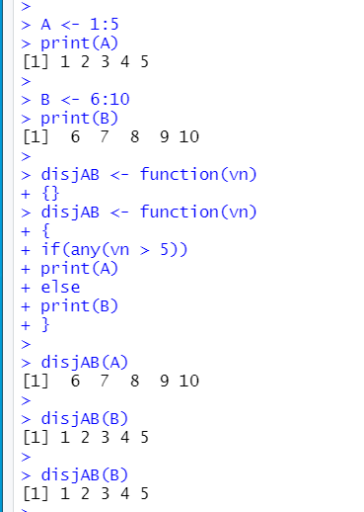

**Explanation of above Implementation:**

**A : 1,2,3,4,5**

**B: 6,7,8,9,10 are two integer vectors defined**

**Here, we need to check: that if A and B are disjoints then integer vector A is to be displayed else if if A and B are not disjoints then integer vector B is to be displayed in this R Programming Code**

**Q.2) Examine the built in ChickWeight data (the help gives background about the data). The function split will prove useful to do the following (as will a script)**

**(a) Construct a plot of weight against time for chick number 34.**

**(b) For chicks in diet group 4, display box plots for each time point.**

**(c) Compute the mean weight for chicks in group 4, for each time point. Plot this mean value against time.**

**(d) Repeat the previous computation for group 2. Add the mean for group 2 to the existing plot**

**Solution 2.) :-**

**2.a) Construct a plot of weight against time for chick number 34.**

**with(ChickWeight,**

**+ plot(df1$weight[34],df1$Time[34],main = "Weight of chick-34 vs Time of chick-34",**

**+ xlab="Weight of chick-34",**

**+ ylab="Time of chick-34",**

**+ ))**

**>**

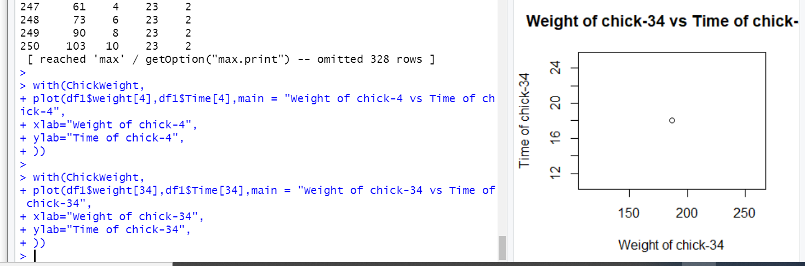

**2.b) For chicks in diet group 4, display box plots for each time point.**

**> with(ChickWeight,**

**+ boxplot(df1$Diet,df1$Time,main = "For chicks in diet group 4, displaying box plots for each time point",**

**+ xlab="chicks in diet group 4",**

**+ ylab="plots for each time point4",**

**+ col = "orange",**

**+ border = "brown",**

**+ horizontal = TRUE,**

**+ notch = TRUE**

**+ ))**

**>**

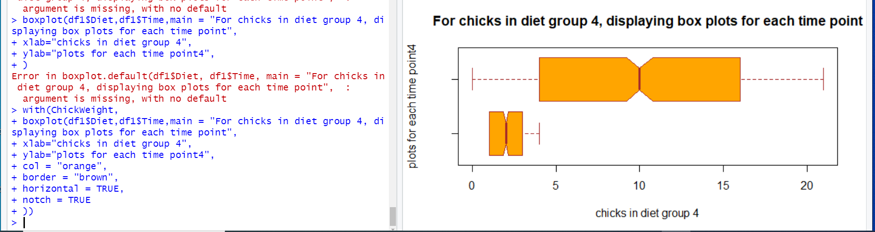

**2. c) Compute the mean weight for chicks in group 4, for each time point. Plot this mean value against time.**

**> mwcg4 <- mean(df1$weight)**

**> mwcg4**

**[1] 121.8183**

**>**

**> with(ChickWeight,**

**+ plot(df1$weight[19],df1$Time[19],main = " The mean weight for chicks in group 4, for each time point Plotted this mean value against time",**

**+ xlab="The mean weight for chicks in group 4, for each time point",**

**+ ylab="Each time point",**

**+ ))**

**>**

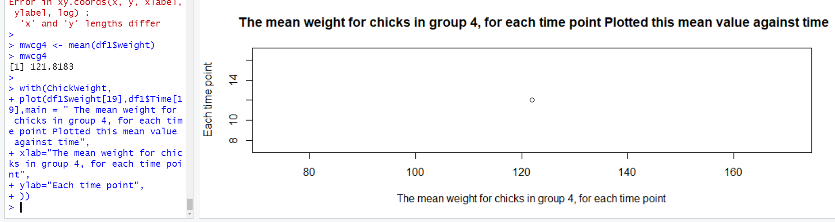

**2. d) Repeat the previous computation for group 2. Add the mean for group 2 to the existing plot.**

**> mwcg2 <- mean(df1$weight)**

**> mwcg2**

**[1] 121.8183**

**>**

**> with(ChickWeight,**

**+ plot(df1$weight[235],df1$Time[235],main = " The mean weight for chicks in group 2, for each time point Plotted this mean value against time",**

**+ xlab="The mean weight for chicks in group 2, for each time point",**

**+ ylab="Each time point",**

**+ ))**

**>**

**> with(ChickWeight,**

**+ plot(df1$weight[235],df1$Time[235],main = " The mean weight for chicks in group 2, for each time point Plotted this mean value against time",**

**+ xlab="The mean weight for chicks in group 2, for each time point",**

**+ ylab="Each time point",**

**+ ))**

**>**

